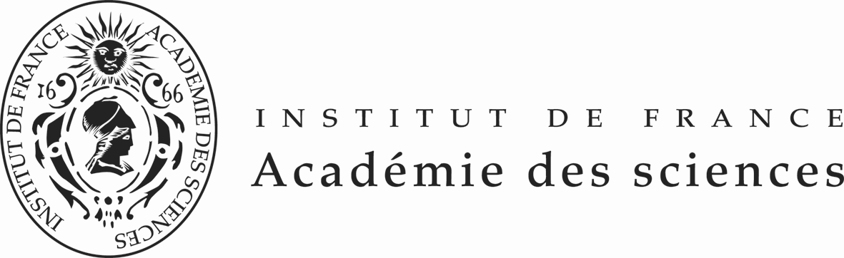

La Fondation Franco-Chinoise
pour la Science et ses Applications (FFCSA)

Post-doctoral Fellowships 2016-2018

(18 months - 24 months in laboratories selected by the FFSCA)

APPLICATION FORM

Gender: | □ Male □ Female
Name Chinese & English: | Chinese English
Surname Chinese & English: | Chinese English
Age & Birth Date:  and Place of birth: | Day / Month / Year  Place of birth
Address of your Home :
Home  Telephone number:  And mobile phone: | Home  Mobile phone
Name and address of your university/institute:
Office :  Tel Fax number | Tel  Fax
Academic Degree PhD | Type  Field  University  Date obtained ( / / )  Day Month Year
Field of specialization:
Title/Current position:
E-mail address:
English language ability  (5:excellent, …..1:poor) | Reading  Writing  Listening  Speaking
Exam passed in english (name, date and mark)  (for information) | English (TOEFL, TSE, GRE, IELTS ….or others)  TOEFL  or  TSE  or  GRE  or  IELTS  ….  Please send to the FFCSA a copy of the certificate of the english exam you have passed
Previous travels abroad | -Places  -Dates  -Purposes
Current links with french research organizations or academics
If you have been previously awarded from the China Scholarship Council (CSC) fellowship or participated in another CSC research program, please indicate the name of the program and the period of your participation

Name of the Program:
Period of participation:

N° | Please mark with an  | Duration  , location and Supervisor of  the Fellowship | Thematic or subject | Desired Profile
1 | □ | 24 months  Dr Raphaël Scharfmann, Paris | Control of pancreatic beta cell development in rodent and human | Medical studies or in biological sciences. Motivated and a good expertise knowledge in experimental biology
2 | □ | 24 months  Mme Rouas -Freiss,  Paris | Immunological properties of mesenchymal stem cells and their applications in transplantation and regenerative medicine. | PhD and strong background in immunology
3 | □ | 24 months  Mme Swiatowska,  Paris | Reactivity of high capacity negative electrode materials used in lithium-ion batteries | The experience in lithium batteries and surface analytical techniques (XPS, TOF-SIMS) will be highly appreciated
4 | □ | 18 months  Christophe Perrin  CIRAD Montpellier | Dissection of molecular mechanisms controlling tissue formation in rice roots  Stem Cells and root development  Root tissue –specific transcriptomic and system biology | Strong Back ground in molecular genetics and good expertise in transcriptomic analyses ( NGS) Interest in Plant. development will also be a positive point
5 | □ | 24 months  CEPH,Paris | Development and applications of bioinformatics tools for Next-Generation Sequencing (NGS) data | very strong background in bioinformatics or related fields (computer science, statistical genetics, mathematics / applied mathematics) and should be familiar with linux / unix environment. Prior experience in the analysis of NGS data is highly desirable. The main tasks will be the development of new methods / algorithms to analyze NGS data.
6 | □ | 24 months  Pierre Mangin Strasbourg | A causal relationship between tumor cells and platelets: The role of platelet integrins β₁ in metastatic dissemination?
7 | □ | 24 months  Hugues de  Thé, Paris | Protein degradation induced by drugs | The candidate should have good training in molecular biology, cell biology and know animal testing.
8 | □ | 18 months  Syrte, Observatoire de Paris | High Precision Inertial Sensors based on Atom Interferometry
9 | □ | 18 months  Laboratoire Kastler Brossel Paris | Atom interferometry and Bloch Oscillations in optical lattice :application to high precision measurements.
10 | □ | 18 months  Christian Hamel  Université de Montpellier | Macular dystrophy of the retina named EMAP for Extended Macular Atrophy with Pseudodrusen.  Analyse of the EMAP exomes and additional sequencing analysis to confirm the linkage of sequencing variants with the pathology. | Interest for genetic research and physiopathology studies using retinal cells obtained from EMAP patients
11 | □ | 24 months  Centre de Recherche en cancérologie Toulouse | New therapeutic strategies for immunotargeting  Non-Hodgkin Lymphomas | Cell immunology, molecular biology, oncology or pharmacology. Methodologies in the lab include cell culture, cellular and molecular biology (cell cloning, Q PCR, transcriptomics, NGS). Analytics include flow cytometry, microscopy, animal models..
12 | □ | 18 months  Laboratoire Aimé Cotton, Orsay | Slowing of molecules by temporary Rydberg electron capture. | Important knowledge in Lasers spectroscopy or in molecular spectroscopy.
13 | □ | 18 months  Institut Charles Gerhardt, Montpellier | Design of Hybrid Nanoporous Materials with high proton conduction. | Interest for using of Electric Impedance and computational tools
14 | □ | 24 months  Laboratoire Kasteler Brossel ,Paris | High-resolution spectrometry of H2+ | An experience of laser spectroscopy and/or ion trapping and cooling is an important asset

- Research Information of the applicant

Summary of current research: Subject of past research and achievements made:

List of major publications ( maximum 6 )
Authors (all), Year, Title, Journal, Vol, N° , pp.-.

PLEASE SEND TO THE FFCSA THE FIRST PAGE OF YOUR PUBLICATIONS

Applicant’s Signature:

I confirm the information given above is true and correct to the best of my knowledge.
I also understand that incomplete application form or application after the deadline
will result in rejection of the application.

Date Signature of the applicant

Date Signature of the Stamp
President/
Director of University /Institute

